CHS Speech & Debate Team Professional Dress Code

Purpose:
The purpose of a professional dress code is to help yourself and the team have a polished image. This gives a fantastic first impression and a lasting impression after competition is said and done. Let’s face it; if you are tied in a round with a competitor who is not dressed professionally, you have the upper hand in a professional competition!

For All:
- ONE of your shirts/ties must be a shade of blue in this chart
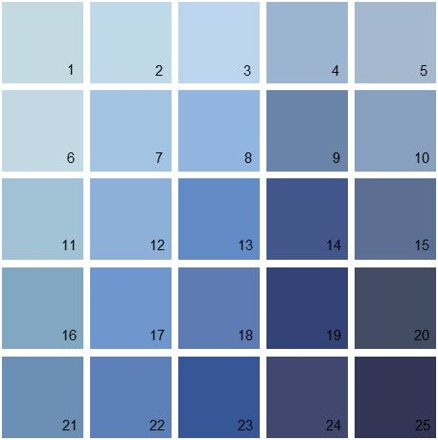
- NO visible tattoos
- NO colored hair (aka: your hair must be a natural looking color)
- NO wacky hair cuts
- NO facial piercings (including nose piercings!)
- You need clothes that fit (not too baggy or tight)
- No bulky watches - INTERP: No watches!
- NO SHORTS when we travel!
- Please do not pair black and navy together
  - It’s too dark of a combo and hard to match

Males:
- Dark Suit (or pants)
- Tie (with no words or pictures on it)
- Plain colored, button up shirt
- Professional shoes
- Hair – clean cut and groomed for competition!
- NO facial hair
- NO earrings or other piercings
- NO bracelets or necklaces
- Debate boys must wear ties. No bowties.
*If you and your partner(s) would ever like to match with a different color scheme, you must talk to me first before buying/wearing those colors, since matching can be difficult with multiple partners.
- Dark socks
- Interp boys must wear solid socks. No patterns.
- No pins or tie clips!

Females:
- Skirt or pant suit (I would rather it be a skirt)
- Skirts- must hit your knees, the slit should not be more than 4 inches from the back of the knee and not in the front. Also, it should not be too tight; it should not ride up when you walk.
We are NOT asking you to go out and spend lots of money!

Needing a suit in Speech & Debate is like needing a helmet in football. Please let us know if you would like to look through the items we have on hand to borrow before you buy something.

- Solid colored blouse (nothing too revealing)
- Simple, closed toed shoes with at least an inch and a-half heel
- Pantyhose (nude) THIS IS NOT AN OPTION
- All jewelry must be pearls (they of course do not need to be real)
  - Stud earrings and a single strand necklace
- All jewelry must be simple and classy (nothing dangly)
- Earrings must be studs
- One hole in ears is the only piercing allowed to show
- No bracelets
- All rings must be simple
- Simple make-up (even if you don’t normally wear make-up)
- lipstick is important (ask about the shade if you’re uncertain)
- Hair should be completely UP – NOT in a ponytail.
  - It must be a clean style, no hair hanging down.
- Only natural color on nails (which means I can’t tell you have polish on) or French Tips is fine too

